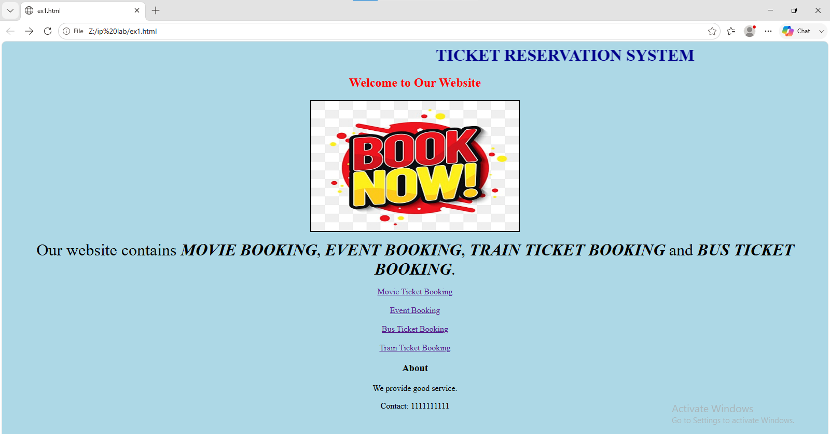

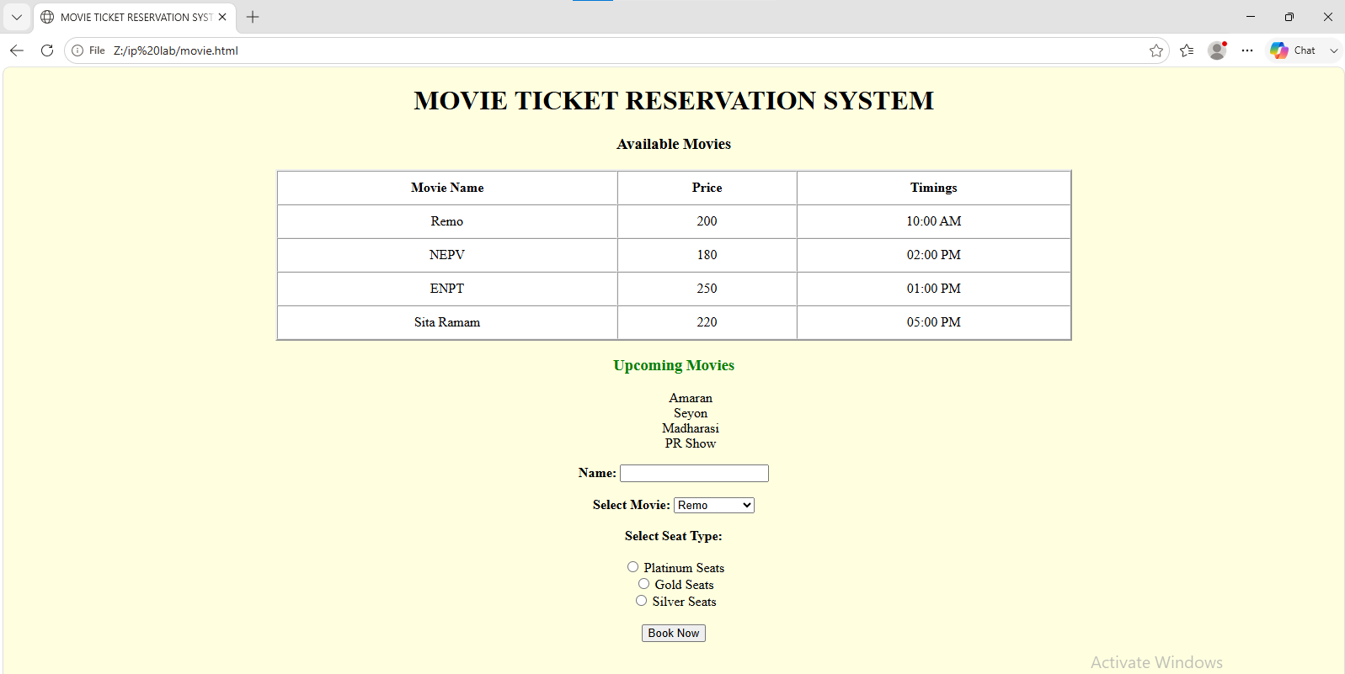

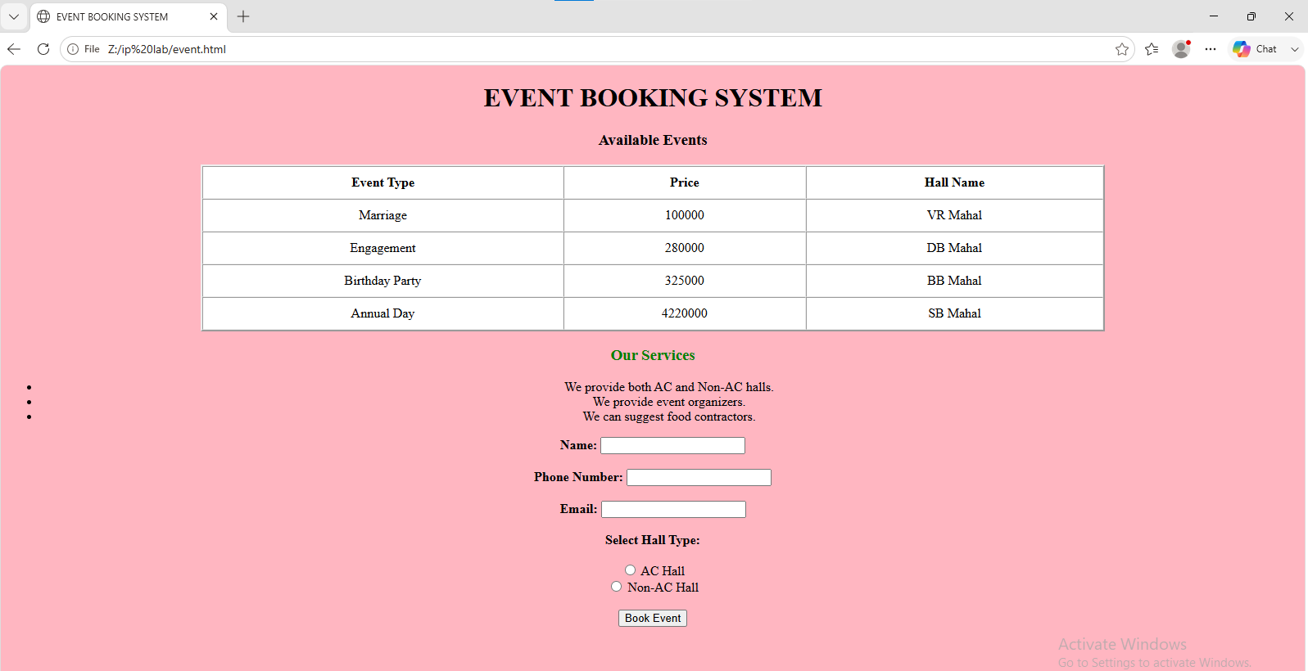

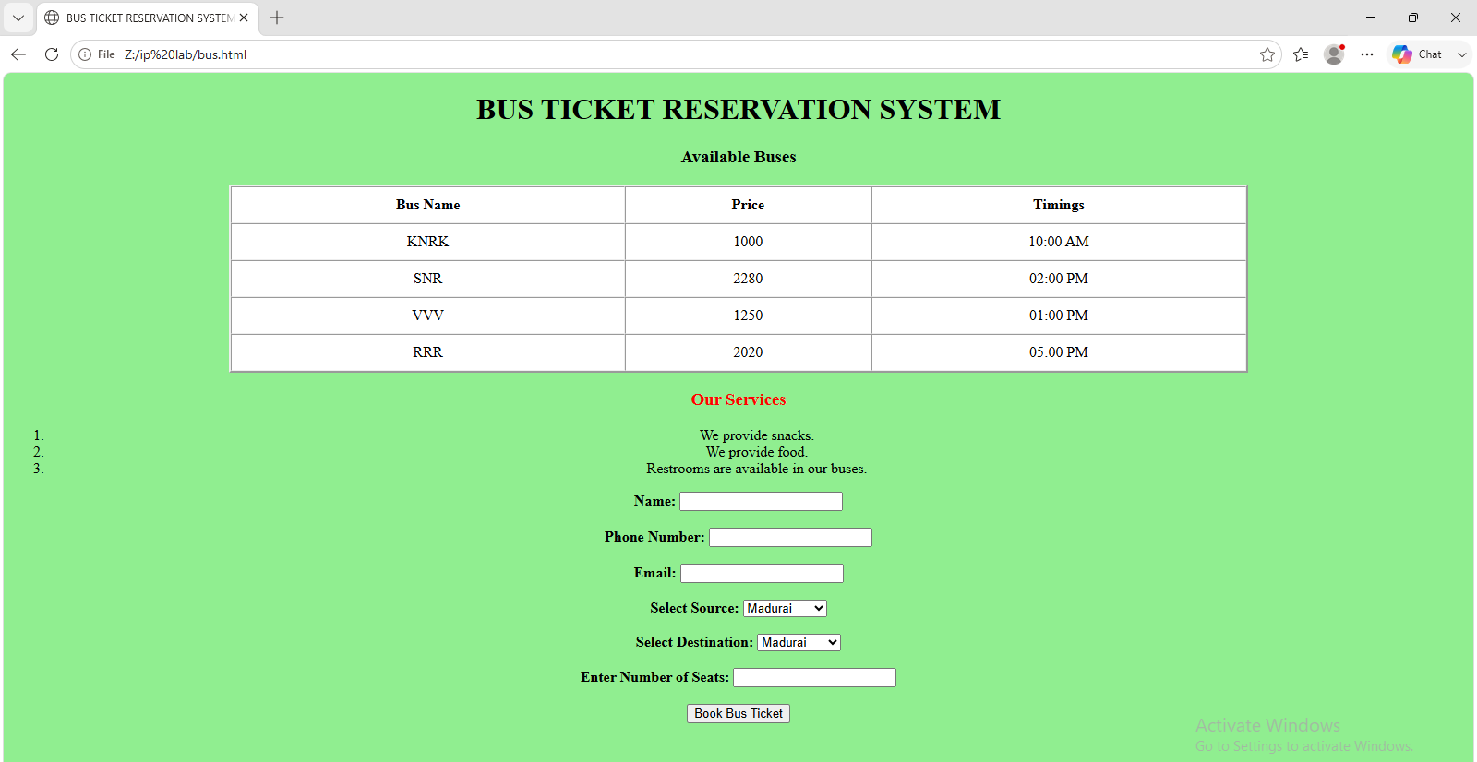

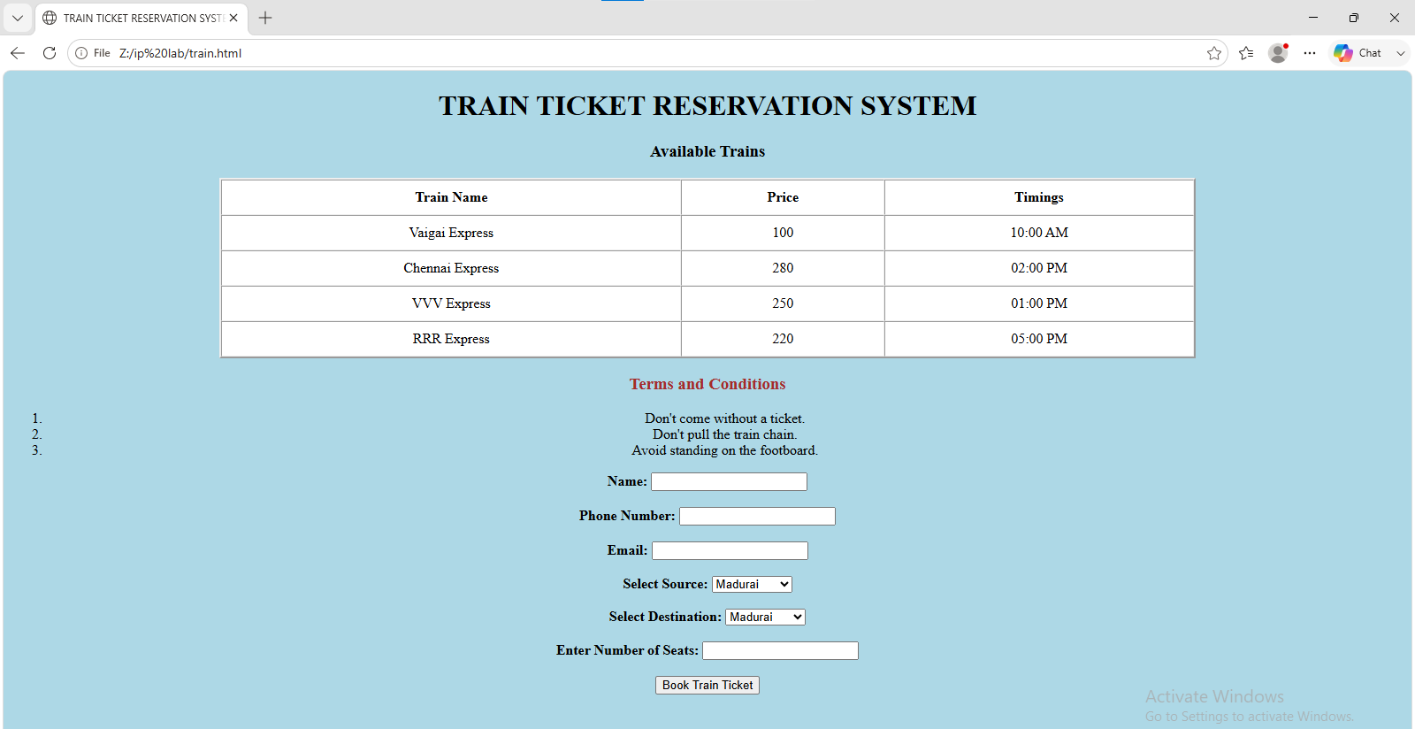
Home.html
<body bgcolor="lightblue">
<h1 align="center">
<marquee behavior="alternate">
<font color="darkblue">TICKET RESERVATION SYSTEM</font>
</marquee>
</h1>
<h2 align="center">
<font color="red">Welcome to Our Website</font>
</h2>
<center>
<img src="Z:\ip lab\img1.png" width="400" height="250" border="2" alt="Event Booking">
</center>
<p align="center">
<font size="6">
Our website contains <b><i>MOVIE BOOKING</i></b>,
<b><i>EVENT BOOKING</i></b>,
<b><i>TRAIN TICKET BOOKING</i></b> and
<b><i>BUS TICKET BOOKING</i></b>.
</font>
</p>
<center>
<a href="movie.html">Movie Ticket Booking</a><br><br>
<a href="event.html">Event Booking</a><br><br>
<a href="bus.html">Bus Ticket Booking</a><br><br>
<a href="train.html">Train Ticket Booking</a>
</center>
<h3 align="center">About</h3>
<p align="center">We provide good service.</p>
<p align="center">Contact: 1111111111</p>
Movie.html
<!DOCTYPE HTML>
<html>
<head>
<title> MOVIE TICKET RESERVATION SYSTEM </title>
</head>
<body bgcolor="lightyellow">
<center>
<h1>MOVIE TICKET RESERVATION SYSTEM</h1>
<h3>Available Movies</h3>
<table border="2" cellpadding="10" cellspacing="0" bgcolor="white" width="60%">
<tr>
<th>Movie Name</th>
<th>Price</th>
<th>Timings</th>
</tr>
<tr align="center">
<td>Remo</td>
<td>200</td>
<td>10:00 AM</td>
</tr>
<tr align="center">
<td>NEPV</td>
<td>180</td>
<td>02:00 PM</td>
</tr>
<tr align="center">
<td>ENPT</td>
<td>250</td>
<td>01:00 PM</td>
</tr>
<tr align="center">
<td>Sita Ramam</td>
<td>220</td>
<td>05:00 PM</td>
</tr>
</table>
<h3>
<font color="green">Upcoming Movies</font>
</h3>
<ul type="none">
<li>Amaran</li>
<li>Seyon</li>
<li>Madharasi</li>
<li>PR Show</li>
</ul>
<form>
<b>Name:</b>
<input type="text" name="name"><br><br>
<b>Select Movie:</b>
<select id="movie" name="movie">
<option>Remo</option>
<option>NEPV</option>
<option>ENPT</option>
<option>Sita Ramam</option>
</select>
<br><br>
<b>Select Seat Type:</b><br><br>
<input type="radio" name="seat"> Platinum Seats<br>
<input type="radio" name="seat"> Gold Seats<br>
<input type="radio" name="seat"> Silver Seats<br><br>
<input type="submit" value="Book Now">
</form>
</center>
</body>
</html>
Event.html
<!DOCTYPE HTML>
<html>
<head>
<title> EVENT BOOKING SYSTEM </title>
</head>
<body bgcolor="lightpink">
<center>
<h1>EVENT BOOKING SYSTEM</h1>
<h3>Available Events</h3>
<table border="2" cellpadding="10" cellspacing="0" width="70%" bgcolor="white">
<tr>
<th>Event Type</th>
<th>Price</th>
<th>Hall Name</th>
</tr>
<tr align="center">
<td>Marriage</td>
<td>100000</td>
<td>VR Mahal</td>
</tr>
<tr align="center">
<td>Engagement</td>
<td>280000</td>
<td>DB Mahal</td>
</tr>
<tr align="center">
<td>Birthday Party</td>
<td>325000</td>
<td>BB Mahal</td>
</tr>
<tr align="center">
<td>Annual Day</td>
<td>4220000</td>
<td>SB Mahal</td>
</tr>
</table>
<h3>
<font color="green">Our Services</font>
</h3>
<ul>
<li>We provide both AC and Non-AC halls.</li>
<li>We provide event organizers.</li>
<li>We can suggest food contractors.</li>
</ul>
<form>
<b>Name:</b>
<input type="text" name="name"><br><br>
<b>Phone Number:</b>
<input type="text" name="phn no"><br><br>
<b>Email:</b>
<input type="text" name="mail"><br><br>
<b>Select Hall Type:</b><br><br>
<input type="radio" name="hall"> AC Hall<br>
<input type="radio" name="hall"> Non-AC Hall<br><br>
<input type="submit" value="Book Event">
</form>
</center>
</body>
</html>
Bus.html
<!DOCTYPE HTML>
<html>
<head>
<title> BUS TICKET RESERVATION SYSTEM </title>
</head>
<body bgcolor="lightgreen">
<center>
<h1>BUS TICKET RESERVATION SYSTEM</h1>
<h3>Available Buses</h3>
<table border="2" cellpadding="10" cellspacing="0" width="70%" bgcolor="white">
<tr>
<th>Bus Name</th>
<th>Price</th>
<th>Timings</th>
</tr>
<tr align="center">
<td>KNRK</td>
<td>1000</td>
<td>10:00 AM</td>
</tr>
<tr align="center">
<td>SNR</td>
<td>2280</td>
<td>02:00 PM</td>
</tr>
<tr align="center">
<td>VVV</td>
<td>1250</td>
<td>01:00 PM</td>
</tr>
<tr align="center">
<td>RRR</td>
<td>2020</td>
<td>05:00 PM</td>
</tr>
</table>
<h3>
<font color="red">Our Services</font>
</h3>
<ol>
<li>We provide snacks.</li>
<li>We provide food.</li>
<li>Restrooms are available in our buses.</li>
</ol>
<form>
<b>Name:</b>
<input type="text" name="name"><br><br>
<b>Phone Number:</b>
<input type="text" name="phn no"><br><br>
<b>Email:</b>
<input type="text" name="mail"><br><br>
<b>Select Source:</b>
<select id="source" name="source">
<option>Madurai</option>
<option>Chennai</option>
<option>Coimbatore</option>
<option>Bangalore</option>
</select>
<br><br>
<b>Select Destination:</b>
<select id="destination" name="destination">
<option>Madurai</option>
<option>Chennai</option>
<option>Coimbatore</option>
<option>Bangalore</option>
</select>
<br><br>
<b>Enter Number of Seats:</b>
<input type="text" name="seats">
<br><br>
<input type="submit" value="Book Bus Ticket">
</form>
</center>
</body>
</html>
Train.html
<!DOCTYPE HTML>
<html>
<head>
<title> TRAIN TICKET RESERVATION SYSTEM </title>
</head>
<body bgcolor="lightblue">
<center>
<h1>
<font >TRAIN TICKET RESERVATION SYSTEM</font>
</h1>
<h3>Available Trains</h3>
<table border="2" cellpadding="10" cellspacing="0" width="70%" bgcolor="white">
<tr>
<th>Train Name</th>
<th>Price</th>
<th>Timings</th>
</tr>
<tr align="center">
<td>Vaigai Express</td>
<td>100</td>
<td>10:00 AM</td>
</tr>
<tr align="center">
<td>Chennai Express</td>
<td>280</td>
<td>02:00 PM</td>
</tr>
<tr align="center">
<td>VVV Express</td>
<td>250</td>
<td>01:00 PM</td>
</tr>
<tr align="center">
<td>RRR Express</td>
<td>220</td>
<td>05:00 PM</td>
</tr>
</table>
<h3>
<font color="brown">Terms and Conditions</font>
</h3>
<ol align="center">
<li>Don't come without a ticket.</li>
<li>Don't pull the train chain.</li>
<li>Avoid standing on the footboard.</li>
</ol>
<form>
<b>Name:</b>
<input type="text" name="name"><br><br>
<b>Phone Number:</b>
<input type="text" name="phn no"><br><br>
<b>Email:</b>
<input type="text" name="mail"><br><br>
<b>Select Source:</b>
<select id="source" name="source">
<option>Madurai</option>
<option>Chennai</option>
<option>Coimbatore</option>
<option>Bangalore</option>
</select>
<br><br>
<b>Select Destination:</b>
<select id="destination" name="destination">
<option>Madurai</option>
<option>Chennai</option>
<option>Coimbatore</option>
<option>Bangalore</option>
</select>
<br><br>
<b>Enter Number of Seats:</b>
<input type="text" name="seats">
<br><br>
<input type="submit" value="Book Train Ticket">
</form>
</center>
</body>
</html>

